**AQAR 2023-2024**

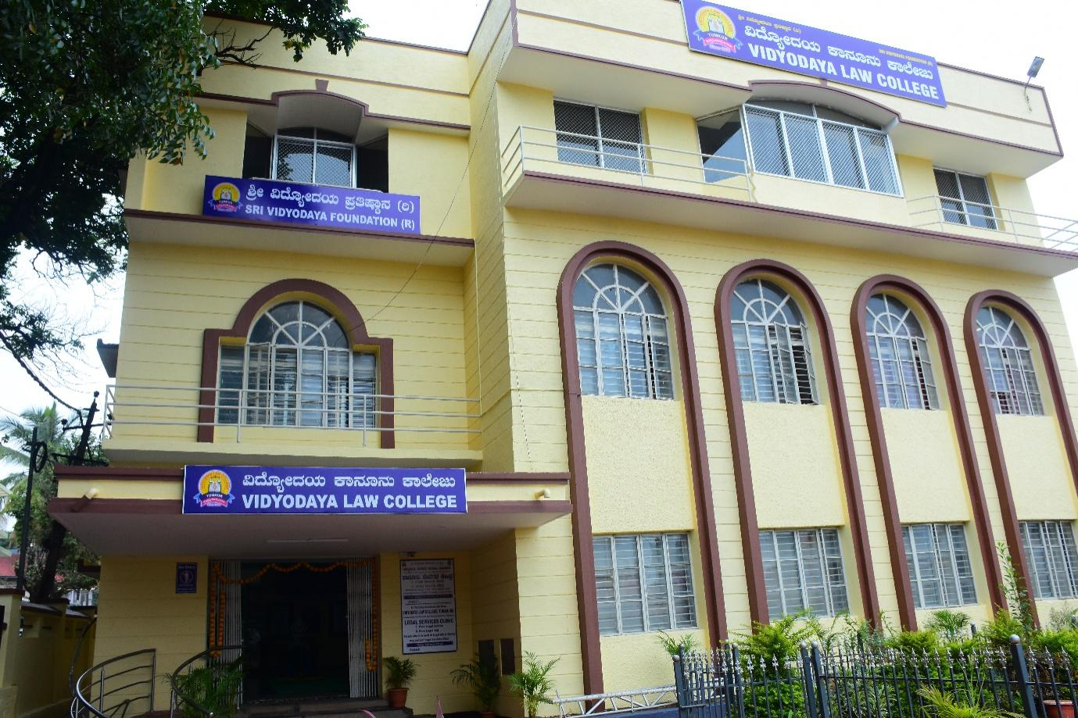

**Criterion 2- Teaching –Learning and Evaluation**

**Key Indicator :- 2.7 - Student Satisfaction Survey**

**Metric No. :- 2.7.1 - Student Satisfaction Survey (SSS) on overall institutional performance (Institution may design its own questionnaire) (results and details need to be provided as a weblink)**

.

***Submitted to***

**THE NATIONAL ASSESSMENT AND ACCREDITATION COUNCIL**

|  |
| --- |
| **Students Details Online Survey**    **file:///C:/Users/vfgc1/OneDrive/Desktop/MNG.pdf** |

